# Kanban – Project Tasks

The prebuilt *Kanban – Project Tasks* provides an overview of registered project tasks in your NetSuite account, with each Kanban column representing the three standard project task status, *Not Started*, *In Progress* and *Completed*. The Column header contains a summary of Remaining work in the columns *Not Started* and *In Progress*. A summary of Actual Work can be found in the columns *In Progress* and *Completed*.

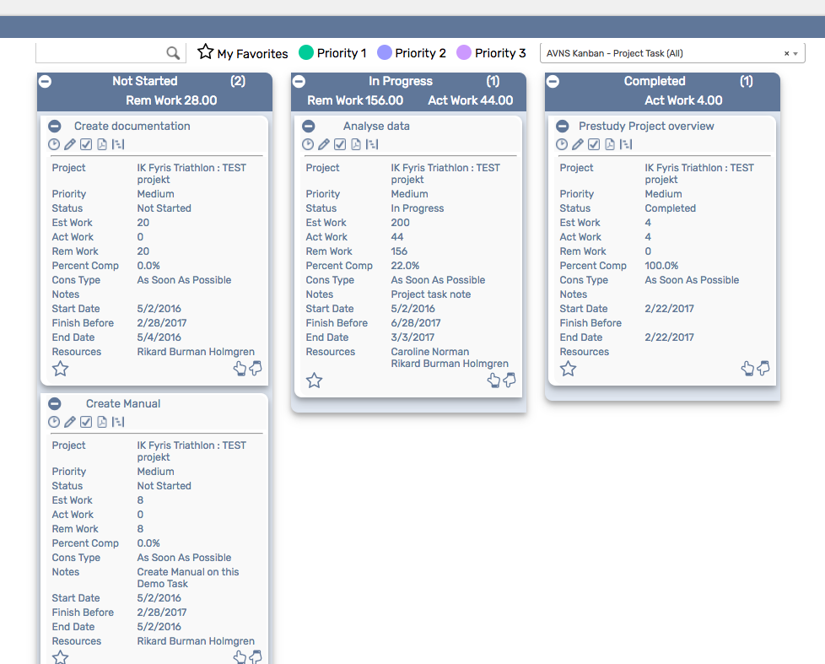

### Kanban – Project Tasks: Prerequisites

Before using the *Kanban – Project Tasks* board, please make sure the prerequisites listed below are fulfilled in order for the board to function as expected.

1. **Time Tracking**  
   The Kanban Project Tasks Board is configured to use the latest Time Tracking feature in NetSuite. If you have not enabled Time Tracking in your NetSuite setup the Time Tracking Icon in the Kanban board will not work properly. Either you switch on Time Tracking in your NetSuite setup or you remove or reconfigure the Time Tracking card action in the Kanban configuration record. (See User Manual for detailed info

### Kanban – Project Tasks: Card Moves & Column Actions

The *Kanban – Projects Tasks* board contains three Kanban Columns representing the standard statuses NOT STARTED, IN PROGRESS and COMPLETED. **Currently, in NetSuite standard, it is not possible to add or remove statuses to Project Tasks.** (But with additional custom record fields a more detailed Kanban Board can be achieved. See example at the end of this documentation). Each column has been configured with several Column Actions. Double clicking on any card in the *Kanban – Project Tasks* board will open the project task record in edit mode. In this Kanban board you are allowed to move all Kanban cards to all columns.



1. **NOT STARTED** 
   1. *Card Moves* – Kanban cards in the column NOT STARTED can be moved to all other columns in the Kanban board.
   2. *Column Actions* – when moving a Kanban card to the column NOT STARTED the status of the record represented in the Kanban card will be updated to NOT STARTED.
2. **IN PROGRESS**
   1. *Card Moves* – Kanban cards in the column IN PROGRESS can be moved to all other columns in the Kanban board.
   2. *Column Actions* – when moving a Kanban card to the column IN PROGRESS the status of the record represented in the Kanban card will be updated to IN PROGRESS.
3. **COMPLETED**
   1. *Card Moves* – Kanban cards in the column COMPLETED can be moved to all other columns in the Kanban board.
   2. *Column Actions* – when moving a Kanban card to the column COMPLETED the status of the record represented in the Kanban card will be updated to COMPLETED.

### Kanban – Project Tasks: Available Card Actions

The Kanban cards in the *Kanban – Projects Tasks* board each contains five Card Actions.

1. 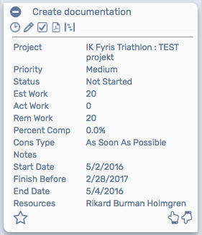**Project Task: Time Tracking**Add a new time tracking to the project task.
2. **Project Task: New Note**Add a new note to the project task.
3. **Project Task: New Project Task**Add a new project task to the parent project record.
4. **Project Task: Project 360 report**Run the Project 360 report for the parent project record.
5. **Project Task: Gantt**Run the Gantt for the parent project record.

### Kanban – Project Tasks: Alternative Searches

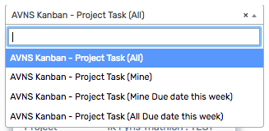There are four alternative searches for the *Kanban – Project Tasks* board.  
  
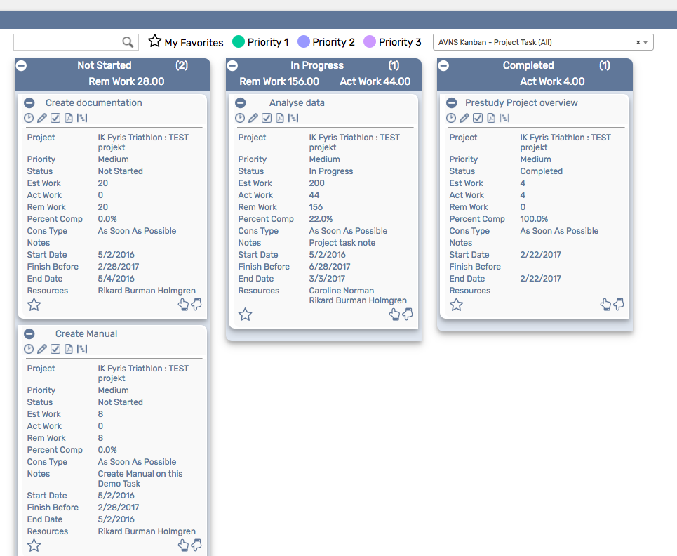

1. **AVNS Kanban Project Task (All)**This search will display all Project Tasks in your NetSuite system.
2. **AVNS Kanban Project Task (Mine)**This search will display all Projects Tasks where you are an assigned resource to the Project Task.
3. **AVNS Kanban Project Task (All Due date this week)**This search will display all Project Tasks where the field “Finish no later than” is within this week.
4. **AVNS Kanban Project Task (Mine Due date this week)**This search will display all Projects Tasks where you are an assigned resource to the Project Task AND where the field “Finish no later than” is within this week.

Additional searches with other search criteria’s can be added in the Kanban configuration record. (For example, searches for specific projects etc.)

### Kanban – Prospects: Available Colors

There are three colors available for the *Kanban – Project Task* board, which can be used to highlight and filter the Kanban cards (*Priority 1 // Priority 2 // Priority 3*). These are defined in the *Color* subtab of the Kanban configuration record.   
  


### Kanban – Project Tasks: Example of a customized Project Board

In the example below we have added 3 customized field on the Project Task record.

1. Project Task Substatus – Which can be a list of values: New, Approved, To do, Doing, Test or Completed.
2. Project Task type – Which can be a list of values: Consulting, Development, Fast track, Internal or Bugg
3. Main responsible – A field linked to the Employee record.

With these 3 extra fields we can create new columns in the Project Task board. Each column respresent the standard status field combined with the new Substatus field. Image on the Main responsible is picked up from the Employee record.

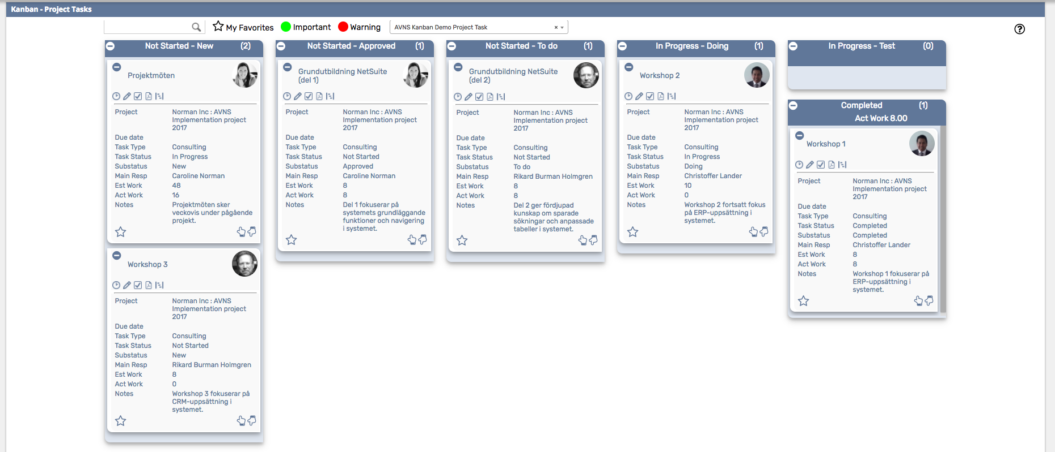

This type of customization was a result of how we, ourselves as a NetSuite Solution Provider, prefere to work with Project Tasks. If you need help with this type of customizations you can always reach out to Alterview for help from our Professional Services Team.